November 18, 2020
TO: Mark Freiberger, Director of Public Works
City of Sedro-Woolley, Public Works Department

FROM: Kirk Harris, PE, Project Manager
Jennifer Salemann, Planner

SUBJECT: DRAFT Task 7 - Summarize Public Outreach Findings Technical Memo

DOCUMENT – INTENT AND PURPOSE
This Technical Memo document that has been prepared for the City of Sedro-Woolley as part of the City’s ADA Self-Evaluation & Transition Plan process. The intent of assessment efforts is not punitive, but rather informative of existing conditions.
An ADA Self-Evaluation & Transition Plan is a document that outlines how jurisdictions transition toward compliance with the Americans with Disabilities Act (ADA). This ADA Title II Self-Evaluation & Transition Plan is being prepared to partially fulfill the requirements set forth in Title II of the ADA. The ADA states that a public entity must reasonably modify its policies, practices, or procedures to avoid discrimination against people with disabilities. This plan will assist the City of Sedro-Woolley to identify policy, program, and physical barriers to accessibility, and to develop barrier removal solutions that will facilitate the opportunity of access to all individuals within the City’s public-right-of-way, buildings, parks, services, programs, and activities.

INTRODUCTION
This memorandum describes the deliverables and recommendations related to Task 7 regarding the public findings gathered from the online surveys, virtual public workshop and follow-up ADA Advisory Group meeting after the virtual public workshop. The memo is organized as follows:
- Deliverables
- Recommendations
- Conclusions
DELIVERABLES

Online Survey Findings
The online SurveyMonkey® and ArcGIS Survey123® surveys yielded a combined total of twenty-eight (28) responses. See Table 1 below. The screen-reader friendly Survey Monkey® version was built to accommodate persons with visual disabilities. This may explain why the majority of respondents selected that survey.

Table 1. Survey Responses by Platform
Survey Platform | Number of Responses
ArcGIS Survey123 | 3
SurveyMonkey | 25
Total | 28

ArcGIS Survey123® Findings
The ArcGIS Survey123® survey was map-enabled (see Figure 1 below). For raw data documentation of the ArcGIS Survey123 responses, see Appendix A.

Three respondents provided feedback to identify general and specific barrier locations. General feedback identified a need to address barriers around schools. One respondent shared, “Central Elementary has a large walker population and the sidewalks and curb ramps in the blocks surrounding it are in horrible shape.” In addition, this respondent identified the downtown business core as another focus area, “the sidewalks surrounding the businesses are in terrible shape and the corner ramps are not cohesive.”

Another respondent who also participated in the virtual public workshop shared that he has inventoried “all of the sidewalks, curb ramps and crosswalks in Sedro Woolley if that would help you. The inventory also includes raised curbs that present difficulty to wheel chair users. The work was done last year so any new improvements would likely not show.”

A third respondent identified a need for a crosswalk at State Street and Reed Street as it is “a place used for jaywalking because the bus stop is on this side street.”

For the ranking questions, the top three (out of six) barriers that respondents want to see removed before others are: missing pedestrian crossings, missing accessible pedestrian signals, and missing curb ramps. The top four (out of seven) important locations at which to remove barriers are: schools/libraries, senior center/elderly care facilities, grocery stores/retail shopping centers, and transit. See Figures 2-3 below.

Note: Ranked question scores were calculated using a weighted average score. Higher scores are for more popular choices. Lower scores are for less popular choices.
Figure 1. ArcGIS Survey123 Survey Map
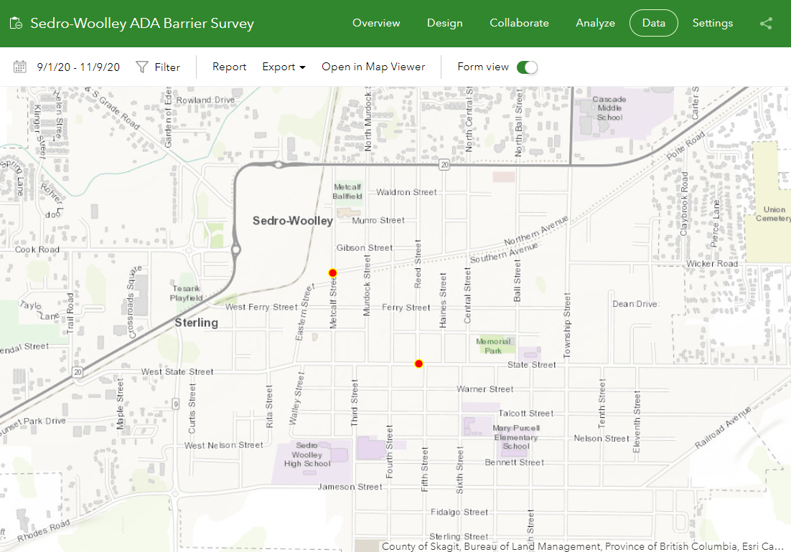
Note: The red dot at the crossing of Metcalf Street and Northern Avenue does not indicate a reported barrier location
(it is the default marker position for survey respondents).

Figure 2. ArcGIS Survey123 Ranked Question Results for Most Wanted Barrier Types for Removal
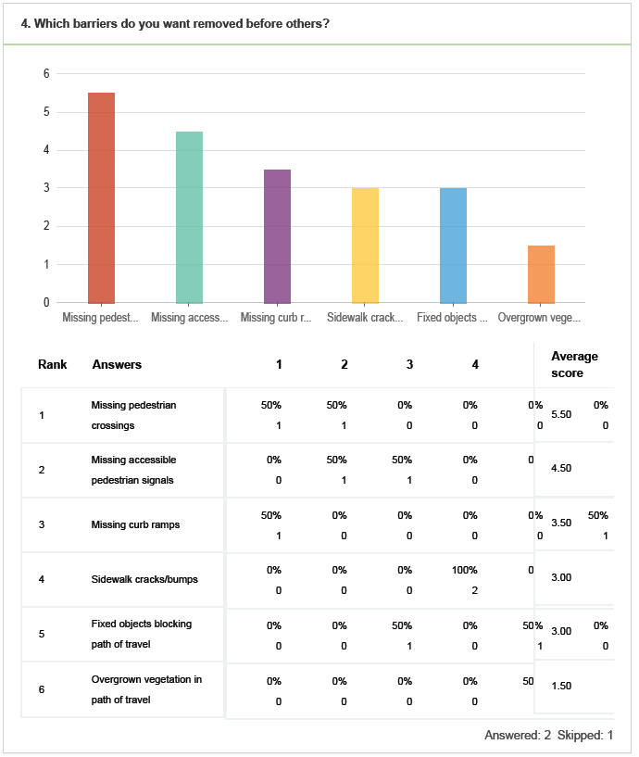

Figure 3. ArcGIS Survey123 Ranked Question Results for Most Wanted Barrier Removal Locations
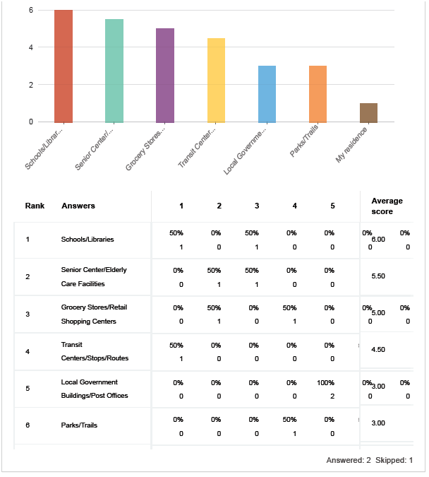

Survey Monkey® Narrative Findings

A summary of the respondents’ barrier descriptions is provided below. The SurveyMonkey® survey was not map-enabled. For raw data documentation of the SurveyMonkey® responses, see Appendix A.

General Observations

- Trail design: Respondent expressed concern for considering best interests of the handicapped and senior citizens as well as equestrian users on Cascade Trail. Respondent cites the Centennial Trail that has pavement as well as graveled sides for horses and horse tracks painted on asphalt where there are horse crossings. Respondent requests that City Council take a field trip to Centennial Trail just past Lake McMurray on Highway 9 to see trail design that accommodates bicyclists, runners, walkers, the handicapped, seniors and equestrian users. Respondent would like to see short, paved section between Dairy Queen and Fruitdale Road continued to be accessible for all.
- Maintenance/Obstacle Clearing: Respondent pointed out barriers can be architectural as well as maintenance related.
- Communication and Employment: A respondent who is blind commented that barriers can be for print materials and employment, as others may have misperceptions of the abilities of qualified blind candidates. Another respondent asked for the website to be more “friendly” to the visually impaired.
- Traffic Signal Phasing/Timing: A respondent who is blind reported that right-on-red traffic takes up available pedestrian crossing time, requiring a blind pedestrian to wait for the next cycle. The respondent advocated for either longer pedestrian crossing times, or push-buttons that would stop the traffic. The respondent shared that audible signals are not always best, as they can mask traffic noise a blind person needs in order to read the traffic.
- Sidewalk Barriers (Cracks, Lack of Ramps, Lack of Sidewalks): A respondent commented that navigating streets with their child in a stroller was difficult due to lack of sidewalks, cracks in sidewalks, and lack of ramps up to sidewalks in neighborhoods of Sedro-Woolley. Another respondent noted a general observation of barriers in high-traffic pedestrian areas and local streets.

Specific Addresses/Locations

- 501 Murdock St; no specific barrier identified
- Cascade Trail: lack of paved surface as barrier
- 722 Cascade Palms Ct: no specific barrier identified
- Intersection of Township St and State St: Three respondents identified this location as having barriers. One respondent cited a need for a wheelchair ramp at the sidewalk near Inspire Church. Another respondent cited State Street east of Township where there are additional missing curb ramps. [Note: Three out of four corners of this intersection do not have curb ramps.]
- Vicinity of High School: The respondent did not identify which high school they were referring to (Sedro-Woolley or State Street High School).
- Section of South Hwy 9 Between State St and Hwy 20: Reported for missing sidewalk segment. [Note: Aerial Google® imagery review of Township/Hwy 9 between State St and Hwy 20 does not appear to have a missing sidewalk segment.]
- Talcott St: Example of high-traffic pedestrian area in need of sidewalks
- Jameson St between 4th St and 5th St: Sidewalk barriers
- 8th Street and Bennett Street (diagonal from Mary Purcell Elementary School): A respondent reported that the sidewalk is blocked by vehicles and covered in gravel so children often walk out into the street on their way to school. [Note: Aerial Google® imagery review of 8th St shows there are no sidewalks on either side between Nelson St. and Dunlop St.]
- Puget Street: Sidewalk barriers

For the ranking questions, the top three (out of six) barriers respondents want to see removed before others are: fixed objects blocking path of travel, overgrown vegetation in path of travel, and sidewalk cracks/bumps. The top four (out of seven) important locations at which to remove barriers are: grocery stores/retail shopping centers, transit centers/stops/routes, senior center/elderly care facilities, and schools/libraries. See Tables 2-3 and Figures 4-5 below.

Note: Ranked question scores were calculated using a weighted average score. Higher scores are for more popular choices. Lower scores are for less popular choices.

Table 2. SurveyMonkey® Ranked Question Results for Most Wanted Barrier Types for Removal - All Data*
 | 1 |  | 2 |  | 3 |  | 4 |  | 5 |  | 6 |  | Total | Score
Missing pedestrian crossings | 0% | 0 | 9% | 2 | 14% | 3 | 27% | 6 | 23% | 5 | 27% | 6 | 22 | 2.55
Fixed objects blocking path of travel | 14% | 3 | 24% | 5 | 33% | 7 | 14% | 3 | 5% | 1 | 10% | 2 | 21 | 4
Missing accessible pedestrian signals | 0% | 0 | 14% | 3 | 10% | 2 | 19% | 4 | 33% | 7 | 24% | 5 | 21 | 2.57
Missing curb ramps | 33% | 7 | 5% | 1 | 19% | 4 | 10% | 2 | 24% | 5 | 10% | 2 | 21 | 3.86
Overgrown vegetation in path of travel | 19% | 4 | 38% | 8 | 14% | 3 | 5% | 1 | 0% | 0 | 24% | 5 | 21 | 4
Sidewalk cracks/bumps | 35% | 8 | 9% | 2 | 9% | 2 | 26% | 6 | 13% | 3 | 9% | 2 | 23 | 4
*Answered: 23. Skipped: 2.

Table 3. SurveyMonkey® Ranked Question Results for Most Wanted Barrier Removal Locations - All Data**
 | 1 |  | 2 |  | 3 |  | 4 |  | 5 |  | 6 |  | 7 |  | Total | Score
Senior Center/Elderly Care Facilities | 23% | 5 | 9% | 2 | 32% | 7 | 0% | 0 | 18% | 4 | 18% | 4 | 0% | 0 | 22 | 4.64
Grocery Stores/Retail Shopping Centers | 27% | 6 | 36% | 8 | 5% | 1 | 5% | 1 | 14% | 3 | 5% | 1 | 9% | 2 | 22 | 5.09
Parks/Trails | 14% | 3 | 5% | 1 | 9% | 2 | 14% | 3 | 9% | 2 | 45% | 10 | 5% | 1 | 22 | 3.45
My residence | 5% | 1 | 5% | 1 | 5% | 1 | 5% | 1 | 0% | 0 | 5% | 1 | 77% | 17 | 22 | 1.86
Schools/Libraries | 5% | 1 | 29% | 6 | 10% | 2 | 29% | 6 | 10% | 2 | 19% | 4 | 0% | 0 | 21 | 4.33
Local Government Buildings/Post Offices | 10% | 2 | 0% | 0 | 19% | 4 | 24% | 5 | 29% | 6 | 10% | 2 | 10% | 2 | 21 | 3.71
Transit Centers/Stops/Routes | 19% | 4 | 14% | 3 | 19% | 4 | 24% | 5 | 24% | 5 | 0% | 0 | 0% | 0 | 21 | 4.81
**Answered: 22. Skipped: 3.

Figure 4. SurveyMonkey® Ranked Question Results for Most Wanted Barrier Types for Removal by Score

Figure 5. SurveyMonkey® Ranked Question Results for Most Wanted Barrier Removal Locations by Score

Ranking Observations Across Both Surveys

Due to the higher number of respondents to the SurveyMonkey® survey, the findings for the ranked questions of that cohort are statistically stronger in comparison to the ArcGIS Survey123® cohort. There was not an overlap for the top types of barriers that respondents wanted to see removed before others. See Table 4 below. For documentation of all survey data, see Appendix A.

Table 4. Comparison of Most Wanted Barrier Types for Removal by Rank
Rank | SurveyMonkey (23 responses) | Score | Rank | ArcGIS Survey123 (2 responses) | Score
1 | Fixed Objects Blocking Path of Travel, Overgrown Vegetation in Path of Travel, Sidewalk Cracks/Bumps | 4 | 1 | Missing Pedestrian Crossings | 5.5
2 | Missing Curb Ramps | 3.86 | 2 | Missing Accessible Pedestrian Signals | 4.5
3 | Missing Accessible Pedestrian Signals | 2.57 | 3 | Missing Curb Ramps | 3.5
4 | Missing Pedestrian Crossings | 2.55 | 4 | Sidewalk Cracks/Bumps | 3
5 |  |  | 5 | Fixed Objects Blocking Path of Travel | 3
6 |  |  | 6 | Overgrown Vegetation in Path of Travel | 1.5

There was overlap for the locations where respondents reported it was most important to remove barriers. The top four out of seven locations were the same, although each survey cohort ranked them within the top four differently. See Table 5 below.

Table 5. Comparison of Most Wanted Locations for Barrier Removal by Rank
Rank | SurveyMonkey (22 responses) | Score* | Rank | ArcGIS Survey123 (2 responses) | Score*
1 | Grocery Stores/Retail Shopping Centers | 5.09 | 1 | Schools/Libraries | 6
2 | Transit Centers/Stops/Routes | 4.81 | 2 | Senior Center/Elderly Care Facilities | 5.5
3 | Senior Center/Elderly Care Facilities | 4.64 | 3 | Grocery Stores/Retail Shopping Centers | 5
4 | Schools/Libraries | 4.33 | 4 | Transit Centers/Stops/Routes | 4.5
5 | Local Government Buildings/Post Offices | 3.71 | 5 | Local Government Buildings/Post Offices, Parks/Trails | 3
6 | Parks/Trails | 3.45 | 6 | My residence | 1.5
7 | My residence | 1.86 | 7

For a map of all identified public outreach barrier locations, see Figure 6.
For a map of all identified public outreach barrier locations and fifty foot TIP (Transportation Improvement Program) projects buffer, see Figure 7 .
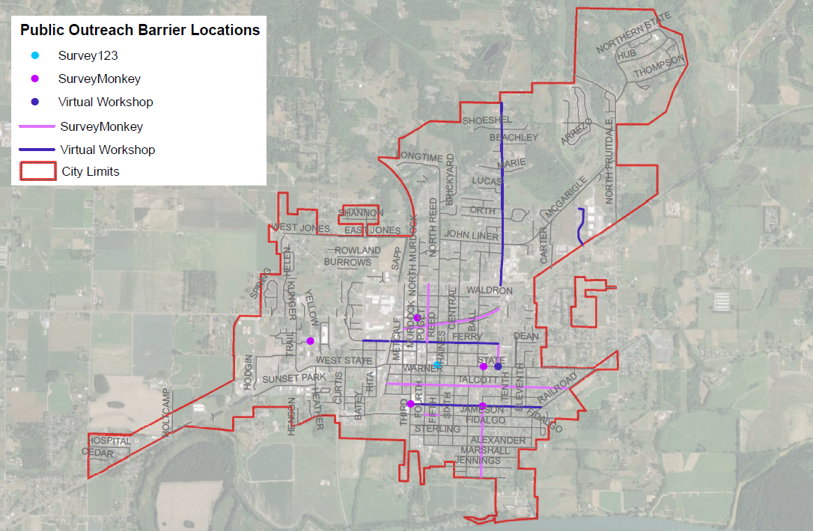
Figure 6. Public Outreach ADA Barrier Findings Map
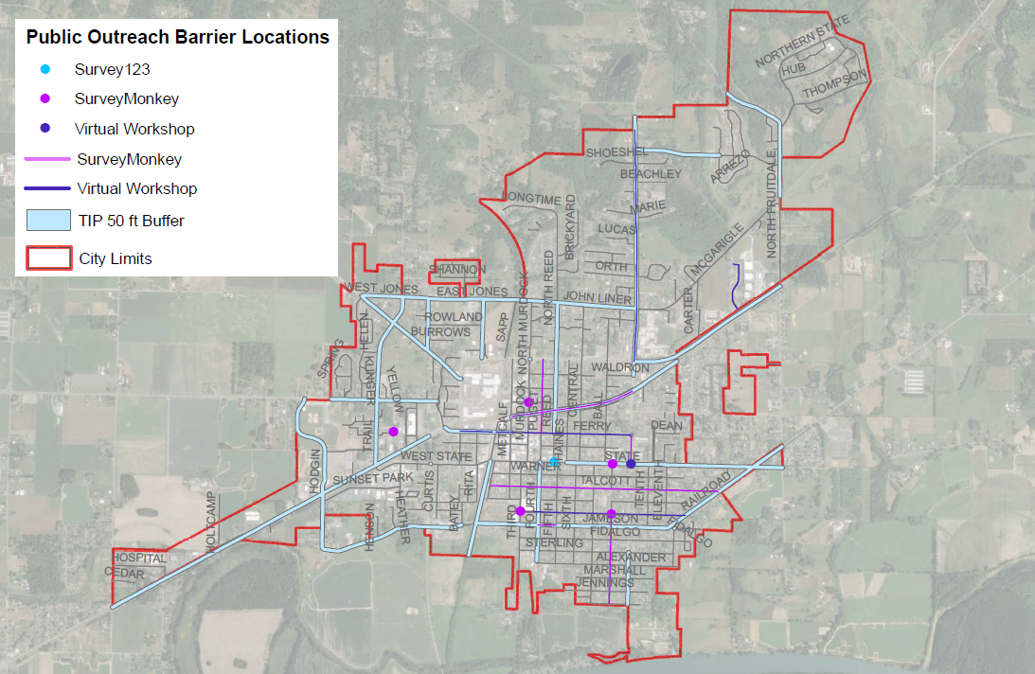
Figure 6. Public Outreach ADA Barrier Findings with 50 Ft TIP Buffer Map

Virtual Public Workshop Findings
Feedback regarding barriers was provided by three participants who are members of the City of Sedro-Woolley ADA Advisory Group and two participants who are local City of Sedro-Woolley residents, one of whom shared that they use a wheelchair mobility device. The remaining participants consisted of three City staff, one Transportation Solutions consultant, and two other Transportation Solutions staff listening in to the workshop as members of the public. For a map of all public outreach identified barrier locations, see Figures 6 and 7 above. For minutes of Virtual Public Workshop, see Appendix B.

Workshop participants identified the following barrier locations and types:
- Mobile Park and Carriage Court: problematic sidewalks and curb ramps*
- Highway 9 north of SR-20: curb ramps without tactile pads
- Ferry Street near the old Heritage Bank: (south side of Ferry at Puget Street: tree roots
- State and Township: missing curb ramps and pedestrian crossings
- Bennett Street: uneven sidewalks
*Note: The City of Sedro-Woolley is responsible for and has authority over the public right of way. Curb ramps or other barriers on private property are the responsibility of private landowners.

Other comments addressed best practices and recommendations for the City:
- Programmatic Observation: Best practices for accommodating persons with disabilities is a positive attitude of City staff, involving the ADA Coordinator as a liaison, and utilizing a network of service providers.
- Ongoing Feedback Platform: either a message form or permanent survey form for members of the public to report barriers to City staff

ADA Advisory Group Debrief on Public Workshop Findings

To be filled in after 12/8 meeting?

RECOMMENDATIONS
It is recommended the City:
- Include documentation of these public outreach findings in the Final ADA Transition Plan.
- Prioritize the specific locations identified by the public as high priority.
- For future updates to the plan, weigh barriers near the following high ranking locations (grocery stores/retail shopping centers, transit centers/stops/routes, senior center/elderly care facilities, and schools/libraries) more heavily than barriers near other locations.
- Consider establishing a dedicated annual budget reserve to address barriers identified by the public. Such a fund will help the City mitigate risk for potential grievances as well as respond to requests by persons with disabilities in the local community who are most affected by barriers to accessibility.
- Utilize the GIS data provided by Clifford Snow to the extent feasible.

CONCLUSIONS

The virtual platform of online surveys and a virtual public workshop provided the public with an accessible and safe participation method in the midst of COVID-19. Online survey participation yielded more participant responses than the virtual public workshop. The public workshop did provide a conversational space to discuss barriers that is otherwise not present in a survey context. The survey findings are helpful in guiding City staff on the selection and scheduling of barrier removal.

The deliverables of this Task 7 Summarize Public Outreach Findings Technical Memo will be documented and referenced in the final ADA Transition Plan.

